# Pandit Deendayal Energy University, Gandhinagar

**School of Technology**

# Department of Computer Science & Engineering

Introduction to Web Technology

**(23CP306P)**



Name: **Ravi Jamanbhai Makwana**

Enrolment No: **21BCP418**

Semester: **5**

Division: **6 (G12)**

Branch: **Computer Science Engineering**

# Practical-1

**Aim:** Design the front pages of a website using HTML and CSS properties

**Hardware Requirement:** HP Laptop

**Software Requirement:** Notepad Version 22H2 / VSCode

**Knowledge Requirement:** Basic understanding of HTML and CSS.

**Theory:** HTML is the standard markup language for Web pages. CSS is the language we use to style an HTML document. HTML (Hypertext Markup Language) and CSS (Cascading Style Sheets) are foundational tools utilized in web development for crafting and designing web pages. Let us delve into a thorough elucidation of HTML and CSS:

## HTML (Hypertext Markup Language):

HTML serves as the foundational framework of web pages, dictating their structure and content through a system of tags, elements, and attributes. Each HTML element has a designated function and can encompass a range of content including text, images, links, and more.

### Tags and Elements:

HTML relies on a set of tags and elements to structure the content on a web page.

Tags are enclosed in angle brackets (<>) and typically come in pairs, consisting of an opening tag and a closing tag.

Elements consist of a pair of tags along with the content they enclose. For example,

<p> serves as an element for paragraphs, containing the actual text of the paragraph.

### Inline and Block Elements:

HTML elements are categorized into two primary types: inline and block.

Inline elements, like <a>, do not start on a new line and only take up as much width as necessary. They are commonly used within text.

Block elements, represented by <p> and <div>, begin on a fresh line and occupy the full width of their container. They are employed for structuring the layout of a page.

### Links and Images:

<a> is utilized to create hyperlinks, equipped with attributes like href (URL) and target (specifying where the linked content should open).

<img> is employed to showcase images, furnished with attributes such as src (image URL) and alt (alternative text for accessibility).

### Lists:

HTML accommodates both unordered lists (<ul>) and ordered lists (<ol>). List items are designated with <li> tags.

### Tables and Definitions:

Tables are established using <table> elements. They may incorporate <caption> for labeling, <thead> for header rows, <th> for header cells, <tbody> for the primary content, and <tfoot> for footer rows.

Definition lists are crafted through <dl>, <dt> for definition titles, and <dd> for definition data.

### Frames and iFrames:

HTML4 employed frames and framesets to partition a web page into multiple sections. HTML5 introduced <iframe> for embedding external content within a page.

## CSS (Cascading Style Sheets):

CSS enhances HTML by offering a means to oversee the presentation and arrangement of web pages. This segregation of content from its visual depiction simplifies the task of administering and upholding websites.

### Selectors and Properties:

* CSS employs selectors to target HTML elements and implement styles on them.
* Properties are utilized to specify how an element's appearance should be, including aspects like color, font size, margins, and more.

### Cascading and Specificity:

* CSS adheres to a cascading sequence, where styles from various origins (e.g., external stylesheets, internal styles, inline styles) can be enforced.
* Specificity dictates which style directives take precedence in situations where multiple rules apply to the same element.

### Box Model:

* The box model stands as a fundamental principle in CSS. Each element is treated as a rectangular box encompassing content, padding, borders, and margins.
* CSS offers control over the dimensions and spacing of these constituents.

### Layout and Positioning:

* CSS equips developers with tools to manage the arrangement of elements on a page.

Techniques such as floats, flexbox, and grid facilitate the creation of intricate layouts.

* Positioning properties (e.g., position, display, z-index) grant control over element placement.

### Responsive Design:

* CSS plays a vital role in crafting responsive web designs that adapt seamlessly to diverse screen sizes and devices.
* Media queries are instrumental in applying styles based on specific screen attributes.

### Transitions and Animations:

* CSS empowers the addition of transitions and animations to elements, enriching user interactions and engagement.

### External Stylesheets:

* CSS can be integrated into web pages via inline <style> tags, internal styles within the

<head> section, or through external stylesheets linked using the <link> element.

By merging HTML and CSS, web developers can craft visually captivating and meticulously structured websites, offering users an exceptional browsing experience. These technologies serve as the bedrock of contemporary web development, enabling the creation of dynamic and interactive web applications.

## Code and Output:

* 1. **Basic HTML- Code-**

<!DOCTYPE html>

<html lang="en">

<head>

<meta charset="UTF-8">

<meta name="viewport" content="width=device-width, initial-scale=1.0">

<title>Introduction</title>

</head>

<body>

<h1>Hello World</h1>

<!-- <h2>Hello World</h2>

<h3>Hello World</h3>

<h4>Hello World</h4>

<h5>Hello World</h5>

<h6>Hello World</h6> -->

<div class="webtech">

<b>Paragraphs:</b>

<p>Lorem ipsum dolor sit amet, consectetur adipisicing elit. Eligendi esse ut temporibus cum enim iure

laboriosam consequatur autem. Minus, excepturi.</p>

<hr>

<p>Lorem ipsum dolor sit amet consectetur, adipisicing elit. Facilis ducimus asperiores, reprehenderit eum

provident officiis neque labore ipsum? Voluptas omnis aliquam numquam, ducimus qui magni.</p>

<br>

<p>Lorem ipsum, dolor sit amet consectetur adipisicing elit. Doloribus voluptas cupiditate saepe repellendus

delectus beatae, eum nam nihil ipsum enim molestiae molestias voluptatem dolore est quasi necessitatibus

non! Sit, praesentium. </p>

</div>

<a href="https://[www.youtube.com"](http://www.youtube.com/) target="_self">Youtube</a>

<br>

<!-- <a href="https://linkedin.com"><img src="pic_trulli.jpg" alt="Italian Trulli"></a>

-->

<ul style="list-style-type: square;">

<li>Coffee</li>

<li>Tea</li>

<li>Milk</li>

</ul>

<ol type="I" start="4">

<li>Coffee</li>

<li>Tea</li>

<li>Milk</li>

</ol>

<!-- Formatting tags -->

<!-- <b> or <strong> -->

<!-- <i> or <em> -->

<!-- <u>

<mark>

<ins>

<del>

<tt>

<sub>

<sup> -->

<!-- strong and bold are same but we use strong for SEO similar is the case for emphasize and italic -->

<b>This is bold text.</b>

<br>

<strong>This is for strong importance.</strong>

<br><u>This is u tag</u>

<p>Today is <del>rainy</del> <ins>sunny</ins> day</p>

<tt>This is Typewriter text.</tt>

<p>x<sub>1</sub></p>

<p>x<sup>2</sup></p>

<!-- HTML Table

<table>

<caption>

<thead>

<th>

<td>

<tr>

<tbody>

<tfoot>

th,thead and tfoot give bold text

Attributes of table - border - compulsory align

cell padding cell spacing bgcolor width

Attributs of tr- rowspan colspan -->

<table border="1" align="center" rules="all" width="200px" height="200px" bgcolor="yellow">

<tr>

<td colspan="2">1</td>

</tr>

<tr>

<td rowspan="2">2</td>

<td>3</td>

</tr>

<tr>

<td>5</td>

</tr>

</table>

<br>

<table border="1" align="center" rules="all" width="500px" height="200px" bgcolor="pink">

<th>Postion</th>

<th>Name</th>

<th>City</th>

<tr>

<td>

<ul type="none">

<li>Sales</li>

<li>Manager</li>

</ul>

</td>

<td>

<ol type="1">

<li>ABC</li>

<li>XYZ</li>

</ol>

</td>

<td>

<ol type="A">

<li>Ahmedabad</li>

<li>Vadodara</li>

</ol>

</td>

</table>

<br>

<table border="1" align="center" rules="all" width="500px" height="200px" bgcolor="aqua">

<tr>

<th rowspan="2">Date</th>

<th colspan="3">Time Table</th>

</tr>

<tr>

<td>CE/IT</td>

<td>EC</td>

<td>MECH</td>

</tr>

<tr>

<td>3/8/23</td>

<td>WT</td>

<td>OC</td>

<td>HVE</td>

</tr>

<tr>

<td>4/8/23</td>

<td>OS</td>

<td>VLSI</td>

<td>CAD</td>

</tr>

</table>

</body>

</html>

## Output-

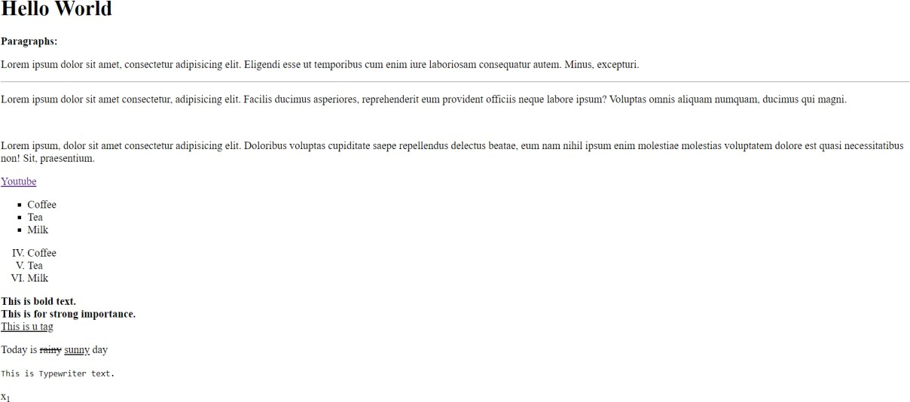

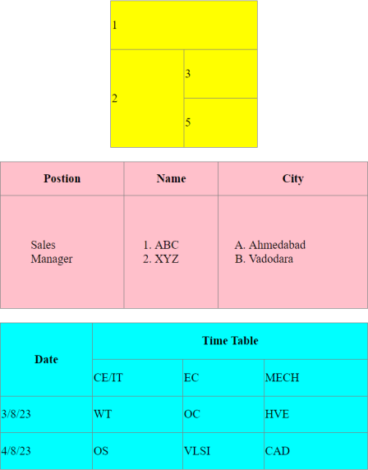

* 1. **Rowspan and colspan- Code-**

<!DOCTYPE html>

<html lang="en">

<head>

<meta charset="UTF-8">

<meta name="viewport" content="width=device-width, initial-scale=1.0">

<title>Rowspan and Colspan</title>

</head>

<body>

<table border="1" align="center" rules="all" width="500px" height="200px">

<tr>

<td rowspan="3" align="center">A</td>

<td align="center">B</td>

<td colspan="2" align="center">C</td>

<td align="center">D</td>

<td rowspan="2" colspan="2" align="center">E</td>

</tr>

<tr>

<td align="center">F</td>

<td align="center">G</td>

<td rowspan="3" align="center">H</td>

<td align="center">I</td>

</tr>

<tr>

<td rowspan="2" align="center">J</td>

<td align="center">K</td>

<td align="center">L</td>

<td align="center">M</td>

<td align="center">N</td>

</tr>

<tr>

<td align="center">O</td>

<td align="center">P</td>

<td colspan="3" align="center">Q</td>

</tr>

</table>

</body>

</html>

## Output-

* 1. **Complex Table a)**

## Code-

<!DOCTYPE html>

<html lang="en">

<head>

<meta charset="UTF-8">

<meta name="viewport" content="width=device-width, initial-scale=1.0">

<title>Complex Table</title>

</head>

<body>

<table border="1" align="center" rules="all" width="900px" height="200px" bgcolor="#90EE90">

<tr>

<td rowspan="2"><img src="./camel.jpg" alt="camel.jpg"></td>

<td colspan="4">

<h1 align="center">Camelid Comparison</h1>

<br>

<br>

<br>

<br>

<p>Approximate as of 6/2007</p>

</td>

</tr>

<tr>

<td align="center"># of Humps</td>

<td align="center">Indigeneous region</td>

<td align="center">Spits?</td>

<td align="center">Produces Wool?</td>

</tr>

<tr>

<td align="center">Camels(backtrian)</td>

<td align="center">2</td>

<td align="center">Africa/Asia</td>

<td align="center">Yes</td>

<td align="center">Yes</td>

</tr>

<tr>

<td align="center">Llamas</td>

<td align="center">1</td>

<td align="center">Andes Mountains</td>

<td align="center">Yes</td>

<td align="center">Yes</td>

</tr>

</table>

</body>

</html>

**Output-**

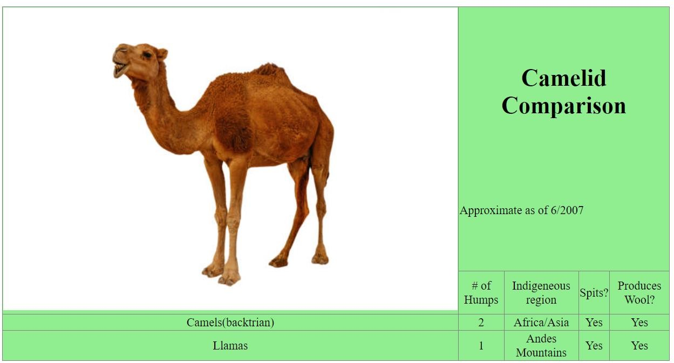

## b) Code-

<!DOCTYPE html>

<html lang="en">

<head>

<meta charset="UTF-8">

<meta name="viewport" content="width=device-width, initial-scale=1.0">

<title>Complex Table 2</title>

</head>

<body>

<h2 align="center">Price of Fruit</h2>

<table border="1" align="center" rules="all" width="300px" height="200px" bgcolor="#CBC3E3">

<th>Fruit</th>

<th>Price</th>

<tr>

<td>Apple</td>

<td>$0.25</td>

</tr>

<tr>

<td>Orange</td>

<td>$0.50</td>

</tr>

<tr>

<td>Banana</td>

<td>$1.00</td>

</tr>

<tr>

<td>Pineapple</td>

<td>$2.00</td>

</tr>

<tr>

<th align="center">Total</th>

<th align="center">$3.75</th>

</tr>

</table>

</body>

</html>

# Output-

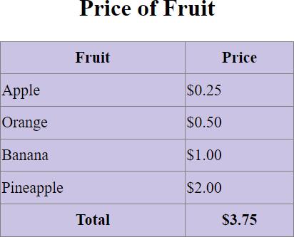

## IFrames- Code-

### radiant_holiday.html-

<!DOCTYPE html>

<html lang="en">

<head>

<meta charset="UTF-8">

<meta name="viewport" content="width=device-width, initial-scale=1.0">

<title>Radiant Holiday</title>

</head>

<frameset rows="20%,10%,*,10%" />

<frame src="./hello.html" frameborder="0">

<frame src="./nav.html" frameborder="-1">

<frameset cols="25%,*,25%">

<frame src="./list.html">

<frame src="./text.html">

<frame src="./form.html">

</frameset>

<frame src="./footer.html" frameborder="0">

</frameset>

</html>

### hello.html-

<!DOCTYPE html>

<html lang="en">

<head>

<meta charset="UTF-8">

<meta name="viewport" content="width=device-width, initial-scale=1.0">

<title>Document</title>

</head>

<body bgcolor="grey">

<center>

<h1>Radiant Holidays</h1>

</center>

</body>

</html>

### nav.html-

<!DOCTYPE html>

<html lang="en">

<head>

<meta charset="UTF-8">

<meta name="viewport" content="width=device-width, initial-scale=1.0">

<title>Document</title>

</head>

<body bgcolor="magenta">

<table width="100%">

<thead width="100%">

<th><a href="">Home</a></th>

<th><a href="">About Us</a></th>

<th><a href="">Gallery</a></th>

<th><a href="">FAQ</a></th>

<th><a href="">Contact Us</a></th>

</thead>

</table>

</body>

</html>

### list.html-

<!DOCTYPE html>

<html lang="en">

<head>

<meta charset="UTF-8">

<meta name="viewport" content="width=device-width, initial-scale=1.0">

<title>Document</title>

</head>

<body bgcolor="lightblue">

<ul type="none">

<li><a href="">Book Hotel</a></li>

<li><a href="">Book Resort</a></li>

<li><a href="">Holiday package</a></li>

<li><a href="">Manange food</a></li>

</ul>

</body>

</html>

### text.html-

<!DOCTYPE html>

<html lang="en">

<head>

<meta charset="UTF-8">

<meta name="viewport" content="width=device-width, initial-scale=1.0">

<title>Document</title>

</head>

<body bgcolor="pink">

<div>Radiant Holidays is a captivating and enchanting experience that invites individuals <br>

to immerse themselves in a world of festive wonder and joy. It is a time when cities and homes<br>

come alive with shimmering lights, vibrant decorations, and a palpable sense of warmth and togetherness. <br>

During Radiant Holidays, families and friends gather to celebrate cherished traditions, exchange heartfelt <br>

gifts, and create lasting memories. Streets are adorned with intricately designed displays, evoking a sense <br>

of magic and delight that transcends age and background. Whether it's the sparkle of twinkling lights,<br>

the aroma of freshly baked treats, or the resonating laughter of children, Radiant Holidays encapsulates the

<br>

essence of the holiday spirit. It's a season that encourages reflection, gratitude, and a spirit of giving,

reminding us all <br>

of the beauty that can be found in the simple moments of connection and celebration.

</div>

</body>

</html>

### form.html-

<!DOCTYPE html>

<html lang="en">

<head>

<meta charset="UTF-8">

<meta name="viewport" content="width=device-width, initial-scale=1.0">

<title>Document</title>

</head>

<body>

<h3>Login</h3>

<a href="#">New User?</a>

<h2>Email</h2>

<input type="textbox">

<h2>Password</h2>

<input type="textbox">

<button>Submit</button>

</body>

</html>

### footer.html-

<!DOCTYPE html>

<html lang="en">

<head>

<meta charset="UTF-8">

<meta name="viewport" content="width=device-width, initial-scale=1.0">

<title>Document</title>

</head>

<body style="background-color: rgb(46, 43, 43);">

<div>CREATED BY RAVI</div>

</body>

</html>

## Output-

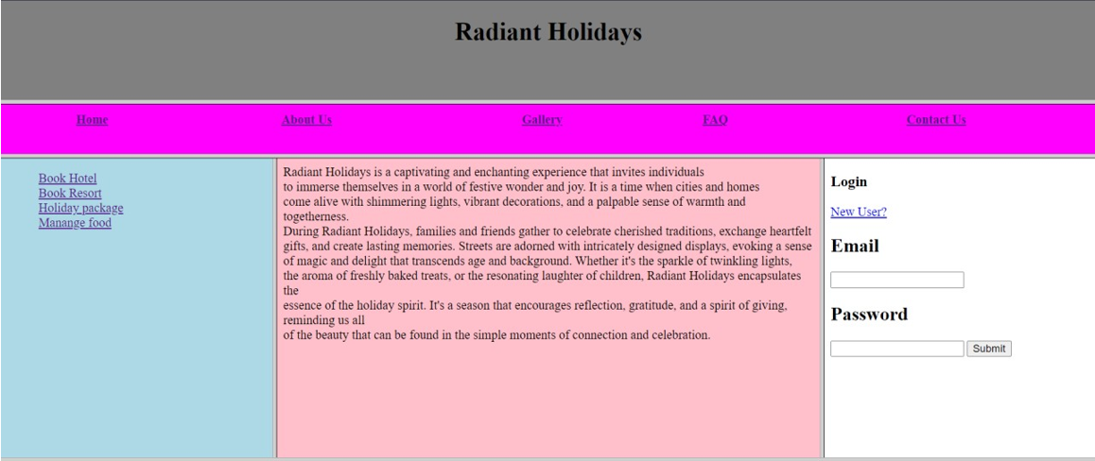



* 1. **HTML form-**

## Code-

<!DOCTYPE html>

<html lang="en">

<head>

<meta charset="UTF-8">

<meta name="viewport" content="width=device-width, initial-scale=1.0">

<title>Registration Form</title>

</head>

<body>

<div align="center">

<form action="">

<fieldset style="width:500px; height:500px">

<legend>Registration page:</legend>

<label for="fname">Employee Name:</label>

<input type="text" name="fname" id="fname"><br><br>

<label for="job">Job :</label>

<select size="4">

<option value="Salesman">Salesman</option>

<option value="Manager">Manager</option>

<option value="Clerk">Clerk</option>

<option value="Analyst">Analyst</option>

</select>

<br><br>

<label for="email">Email:</label>

<input type="email" id="email" name="email" /> <br>

<br>

<label for="password">Password:</label>

<input type="Password" id="pass" name="pass"> <br>

<br>

<label for="re-pass">Re-Type Password:</label>

<input type="Password" id="repass" name="repass" placeholder="Confirm Your Password"> <br><br>

<label for="gender">Gender:</label>

<input type="radio" name="gender"> Male

<input type="radio" name="gender"> Female

<br><br>

<label for="birthday">Birthday:</label>

<input type="Birthday" id="birth" name="birth"> <br>

<br>

<label for="salary">Salary:</label>

<input type="salary" id="sal" name="sal"> <br>

<br>

<label for="Commission">Commission:</label>

<input type="Password" id="pass" name="pass"> <br>

<br>

<label for="Total Salary">Total Salary:</label>

<input type="total" id="total" name="total" value="NaN"> <br>

<br>

<input type="submit" value="Submit" />

<input type="reset" value="Reset" />

</fieldset>

</form>

</div>

</body>

</html>

## Output-

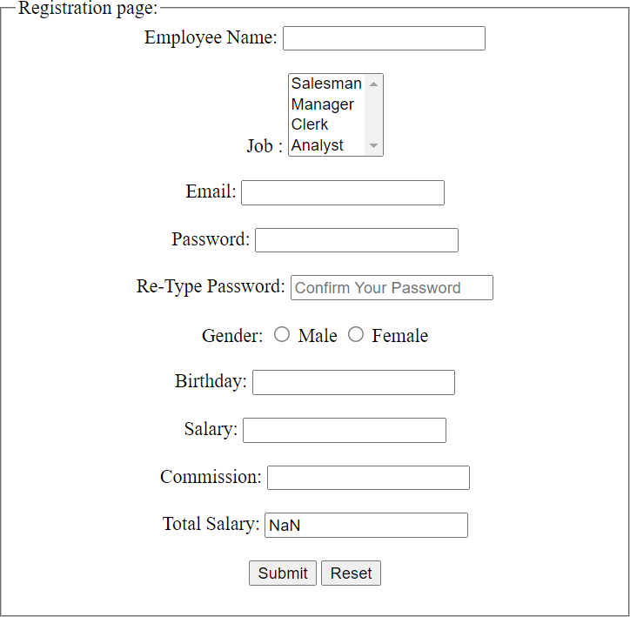

* 1. **Questions-**

## Write HTML and CSS script to display two tables of 50%, 50% width having 6 columns and 6 rows.

* **Add random data to table.**

## These two tables must be horizontally adjacent to each other.

* **Make responsive web page. Initially first table should have light blue color and second table should have light green color.**

## When page comes to portrait mode, colors of tables should be reversed.

**Ans. CODE-**

<!DOCTYPE html>

<html lang="en">

<head>

<meta charset="UTF-8">

<meta name="viewport" content="width=device-width, initial-scale=1.0">

<title>Responsive Tables</title>

<style>

body {

font-family: Arial, sans-serif; margin: 0;

}

.container { display: flex;

}

.table-container { width: 50%;

box-sizing: border-box; padding: 20px;

}

table {

width: 100%;

border-collapse: collapse;

}

th,

td {

padding: 8px; text-align: left;

border-bottom: 1px solid #ddd;

}

th {

background-color: #f2f2f2;

}

.table-1 {

background-color: lightblue; margin-top: 100px;

}

.table-2 {

background-color: lightgreen; margin-top: 100px;

}

@media screen and (max-width: 900px) {

.container {

flex-direction: column;

}

.table-container { width: 100%;

}

.table-1 {

background-color: lightgreen;

}

.table-2 {

background-color: lightblue;

}

}

</style>

</head>

<body>

<div class="container">

<div class="table-container table-1">

<h2>Table 1</h2>

<table>

<tr>

<th>First Name</th>

<th>Middle Name</th>

<th>Last Name</th>

<th>Roll No.</th>

<th>Branch</th>

<th>Passing Year</th>

</tr>

<tr>

<td>John</td>

<td>Doe</td>

<td>Smith</td>

<td>12345</td>

<td>Computer Science</td>

<td>2023</td>

</tr>

<tr>

<td>Jane</td>

<td>Lee</td>

<td>Brown</td>

<td>54321</td>

<td>Electrical Engineering</td>

<td>2022</td>

</tr>

<tr>

<td>Michael</td>

<td>James</td>

<td>Johnson</td>

<td>98765</td>

<td>Mechanical Engineering</td>

<td>2024</td>

</tr>

<tr>

<td>Susan</td>

<td>Mary</td>

<td>Clark</td>

<td>67890</td>

<td>Chemical Engineering</td>

<td>2023</td>

</tr>

<tr>

<td>David</td>

<td>Paul</td>

<td>Anderson</td>

<td>45678</td>

<td>Civil Engineering</td>

<td>2022</td>

</tr>

<tr>

<td>Emily</td>

<td>Rose</td>

<td>Taylor</td>

<td>23456</td>

<td>Information Technology</td>

<td>2024</td>

</tr>

</table>

</div>

<div class="table-container table-2">

<h2>Table 2</h2>

<table>

<tr>

<th>Name</th>

<th>Age</th>

<th>City</th>

<th>Country</th>

<th>Occupation</th>

<th>Salary</th>

</tr>

<tr>

<td>John Doe</td>

<td>32</td>

<td>New York</td>

<td>USA</td>

<td>Engineer</td>

<td>75,000</td>

</tr>

<tr>

<td>Jane Smith</td>

<td>28</td>

<td>London</td>

<td>UK</td>

<td>Designer</td>

<td>50,000</td>

</tr>

<tr>

<td>Michael Johnson</td>

<td>35</td>

<td>Toronto</td>

<td>Canada</td>

<td>Doctor</td>

<td>90,000</td>

</tr>

<tr>

<td>Susan Davis</td>

<td>30</td>

<td>Sydney</td>

<td>Australia</td>

<td>Teacher</td>

<td>60,000</td>

</tr>

<tr>

<td>David Brown</td>

<td>29</td>

<td>Berlin</td>

<td>Germany</td>

<td>Software Developer</td>

<td>65,000</td>

</tr>

<tr>

<td>Emily Taylor</td>

<td>31</td>

<td>Tokyo</td>

<td>Japan</td>

<td>Marketing Manager</td>

<td>70,000</td>

</tr>

</table>

</div>

</div>

</body>

</html>

**Output-**

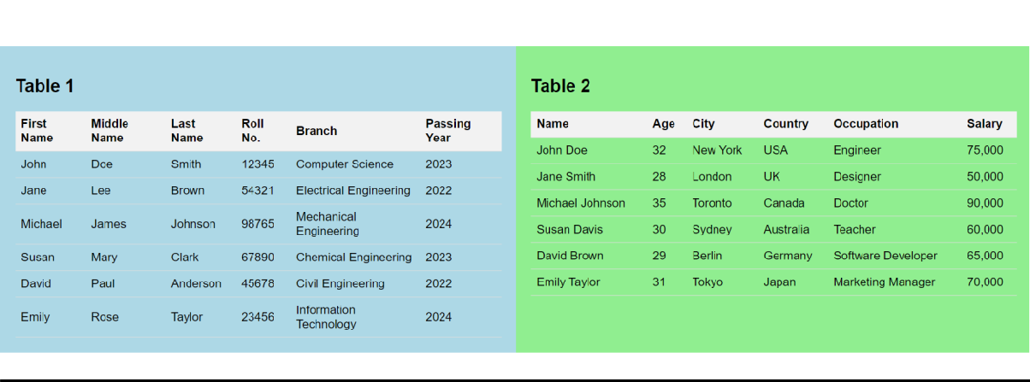

## Write HTML and CSS script to design one login form having fields like username, password, submit button and reset button.

* + - * **While hovering each control, it should be expanded around 20% horizontally and vertically with delay of 2 seconds.**

## Expansion should take place in 4 seconds.

**Ans. Code-**

<!DOCTYPE html>

<html lang="en">

<head>

<meta charset="UTF-8">

<meta name="viewport" content="width=device-width, initial-scale=1.0">

<title>Login Form</title>

<style>

body {

font-family: Arial, sans-serif; display: flex;

justify-content: center; align-items: center; height: 100vh; margin: 0;

}

.form-container { width: 300px;

background-color: #f8f8f8; padding: 20px;

border-radius: 10px;

box-shadow: 0 4px 8px rgba(0, 0, 0, 0.1); text-align: center;

transition: transform 4s ease;

}

.form-container:hover { transform: scale(1.2);

}

input[type="text"], input[type="password"] {

width: 100%; padding: 10px; margin: 10px 0;

box-sizing: border-box; border: 1px solid #ccc; border-radius: 4px;

}

input[type="submit"], input[type="reset"] {

padding: 10px 20px; margin: 10px 5px;

box-sizing: border-box; border: none;

border-radius: 4px; cursor: pointer;

}

input[type="submit"] { background-color: #4caf50; color: #fff;

}

input[type="reset"] { background-color: #f44336; color: #fff;

}

</style>

</head>

<body>

<div class="form-container">

<h2>Login Form</h2>

<form>

<input type="text" name="username" placeholder="Username" required><br>

<input type="password" name="password" placeholder="Password" required><br>

<input type="submit" value="Submit">

<input type="reset" value="Reset">

</form>

</div>

</body>

</html>

## Output-

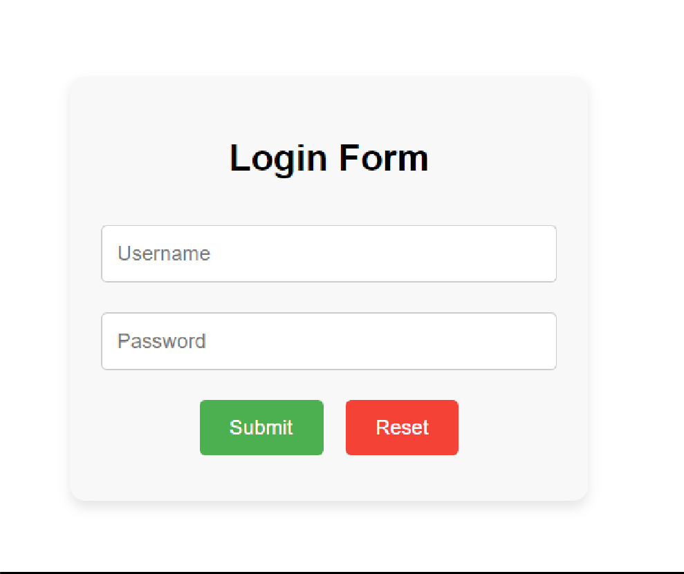

* + 1. **Write HTML and CSS script to take one square division and it should complete a square cycle by changing its color.**

## Ans. Code-

<!DOCTYPE html>

<html lang="en">

<head>

<meta charset="UTF-8">

<meta name="viewport" content="width=device-width, initial-scale=1.0">

<title>Color Changing Square</title>

<style>

.square {

width: 100px; height: 100px;

background-color: red; animation: colorCycle 4s infinite; margin: 200px;

}

@keyframes colorCycle {

0%,

100% {

background-color: red;

}

25% {

background-color: blue;

}

50% {

background-color: green;

}

75% {

background-color: yellow;

}

}

</style>

</head>

<body>

<div class="square"></div>

</body>

</html>

**Output-**



## Write and HTML & CSS script to make a hoverable link button having blue border and white background initially. While hovering, border should disappear and entire button should get blue color with

**transition and pointer effect. Store blue color in CSS variable, since it is used frequently.**

## Ans. Code-

<!DOCTYPE html>

<html lang="en">

<head>

<meta charset="UTF-8">

<meta name="viewport" content="width=device-width, initial-scale=1.0">

<title>Hoverable Link Button</title>

<style>

:root {

--button-background: #ffffff;

/* Define blue color as a CSS variable */

}

.custom-button { display: inline-block; padding: 10px 20px; text-decoration: none;

color: var(--button-background);

background-color: var(--button-background); border: 2px solid #3498db;

transition: background-color 0.3s, border-color 0.3s, color 0.3s; cursor: pointer;

margin: 250px;

}

.custom-button:hover { background-color: #3498db; border: none;

color: #ffffff;

}

</style>

</head>

<body>

<a href="#" class="custom-button">Hover Me</a>

</body>

</html>

**Output-**

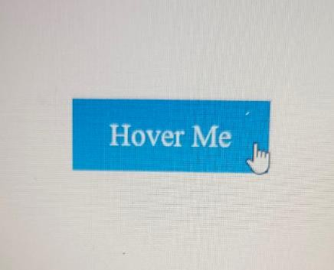

## Write and HTML & CSS script to design one banner of advertisement using <p> tag. That text of advertise should move continuously from left end to right end, then return back from right to left end. Use red and huge fonts for text. Advertise should begin after 1 second of loading page.

**Ans. Code-**

<!DOCTYPE html>

<html lang="en">

<head>

<meta charset="UTF-8">

<meta name="viewport" content="width=device-width, initial-scale=1.0">

<title>Advertisement Banner</title>

<style>

.banner {

font-size: 36px; color: red;

white-space: nowrap; position: relative; overflow: hidden; width: 100%; background-color: #fff; text-align: center;

animation: moveText 8s linear infinite;

}

@keyframes moveText { 0% {

transform: translateX(-100%);

}

50% {

transform: translateX(0);

}

100% {

transform: translateX(100%);

}

}

</style>

</head>

<body>

<div class="banner">

<p>Discount!!!</p>

</div>

</body>

</html>

**Output-**



## 7.

1. **Write HTML and CSS script to create a table with 5 rows and 3 columns. Even no. of rows should be displayed in red color and odd no. of rows should be displayed in yellow color. Use external CSS file.**

## Ans. Code-

<!DOCTYPE html>

<html lang="en">

<head>

<meta charset="UTF-8">

<meta name="viewport" content="width=device-width, initial-scale=1.0">

<link rel="stylesheet" href="style.css">

<title>7.1</title>

</head>

<body>

<table class="table">

<tr>

<th>Name</th>

<th>Age</th>

<th>Email</th>

</tr>

<tr>

<td>John Doe</td>

<td>25</td>

<[td>john@e](mailto:john@example.com)xam[ple.com</td>](mailto:john@example.com)

</tr>

<tr>

<td>Jane Doe</td>

<td>30</td>

<[td>ja](mailto:jane@example.com)ne@[example.com</td>](mailto:jane@example.com)

</tr>

<tr>

<td>Bob Smith</td>

<td>35</td>

<[td>bob@](mailto:bob@example.com)exa[mple.com</td>](mailto:bob@example.com)

</tr>

<tr>

<td>Alice Johnson</td>

<td>28</td>

<[td>a](mailto:alice@example.com)lic[e@example.com</td>](mailto:alice@example.com)

</tr>

<tr>

<td>Mary Brown</td>

<td>40</td>

<[td>ma](mailto:mary@example.com)ry@[example.com</td>](mailto:mary@example.com)

</tr>

</table>

</body>

</html>

**Output-**

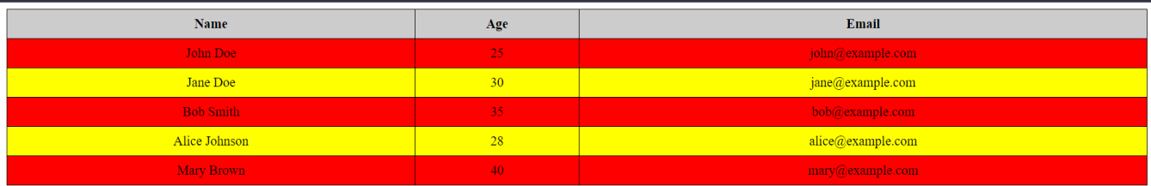

## Write following style in separate CSS file:

* + **Heading should have normal font style and size should be 120%.**

## Define a class arial for paragraph with arial face and bold text and 3cm spacing before paragraph initialization.

**Apply a background image hello.jpg repeating vertically only.**

## Ans. Code-

<!DOCTYPE html>

<html lang="en">

<head>

<meta charset="UTF-8">

<meta name="viewport" content="width=device-width, initial-scale=1.0">

<link rel="stylesheet" href="style.css">

<title>Index 2</title>

</head>

<body>

<h1>This is a Heading 1</h1>

<p class="arial">This is a paragraph with Arial font and bold text.</p>

</body>

</html> h1 {

font-style: normal; color: red;

font-size: 120%;

}

.arial {

font-family: Arial, sans-serif; font-weight: bold; color:red; margin-left: 3cm;

}

body {

background-image: url("./pic_trulli.jpg"); background-repeat: repeat-y; background-size: auto 250%;

}

**Output-**

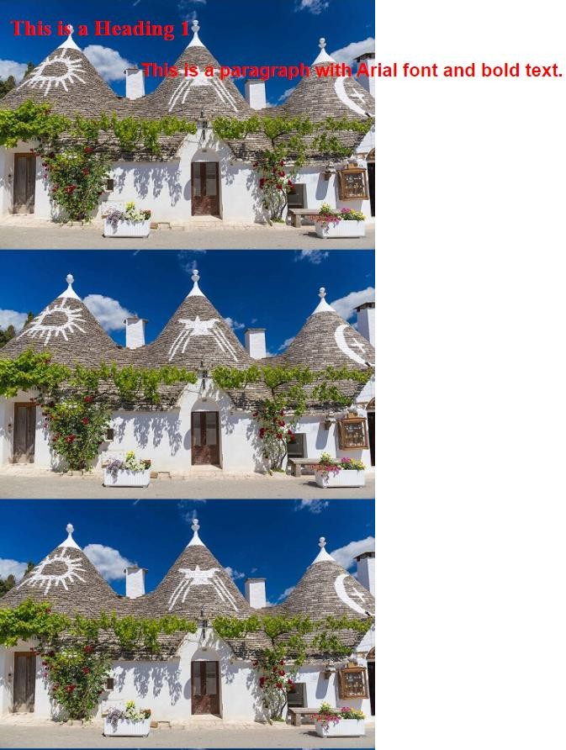

## Write HTML and CSS snippet for following effects: Link: after visited red color and before visited blue color. Table with odd rows pink and even rows blue color.

**Text color-green, Text-indentation-2cm, Text case-Uppercase**

## Ans. Code-

<!DOCTYPE html>

<html lang="en">

<head>

<meta charset="UTF-8">

<meta name="viewport" content="width=device-width, initial-scale=1.0">

<link rel="stylesheet" href="style.css">

<title>7.3</title>

</head>

<body>

<p><a href="https://[www.youtube.com/](http://www.youtube.com/)" class="YouTube">YouTube</a></p>

<table class="table">

<tr>

<td>John Doe</td>

</tr>

<tr>

<td>Jane Doe</td>

</tr>

<tr>

<td>Bob Smith</td>

</tr>

<tr>

<td>Alice Johnson</td>

</tr>

<tr>

<td>Mary Brown</td>

</tr>

</table>

<p class="styled-text">This is a dummy text with red color, 2cm text-indent, and capital letters.</p>

</body>

</html>

.YouTube:link { color: blue;

}

.YouTube:visited { color: red;

}

.table {

border-collapse: collapse; width: 100%;

}

.table td {

border: 1px solid black;

padding: 8px; text-align: center;

}

.table tr:nth-child(odd) { background-color: pink;

}

.table tr:nth-child(even) { background-color: blue;

}

.styled-text { color: green;

text-indent: 2cm;

text-transform: uppercase;

}

**Output-**

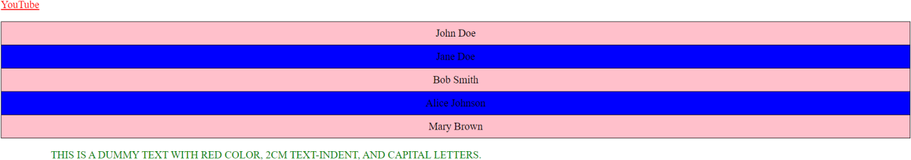

## Write HTML and CSS script to check all pseudo classes on heading tags, paragraph tags, table tags and pre tag. Comment on which pseudo class works on which tag.

**Ans. Code-**

<!DOCTYPE html>

<html lang="en">

<head>

<meta charset="UTF-8">

<meta name="viewport" content="width=device-width, initial-scale=1.0">

<link rel="stylesheet" href="style.css">

<title>Index 4</title>

</head>

<body>

<h1>Welcome to the Fictional Library</h1>

<h2>Featured Books</h2>

<p>Explore a world of imagination with our carefully curated collection of novels.</p>

<table>

<tr>

<td>The Adventure Begins</td>

<td>John Doe</td>

</tr>

<tr>

<td>Mystery in the Manor</td>

<td>Jane Doe</td>

</tr>

</table>

<pre>

Chapter 1:

It was a dark and stormy night...

</pre>

</body>

</html>

/* Basic styles */

h1, h2, p, table, pre { margin-bottom: 20px; padding: 10px; border: 1px solid black;

}

/* Pseudo-classes */ h1:hover { background-color: yellow;

}

h2:hover {

background-color: blue;

}

p:hover {

font-size: 20px;

}

table:hover {

background-color: lightgray;

}

pre::selection {

background-color: yellow; color: red;

}

**Output-**

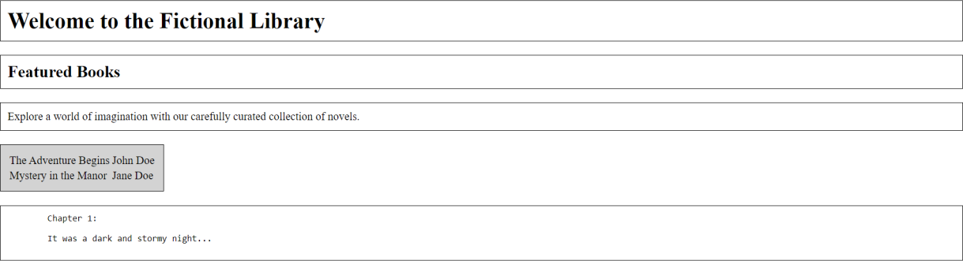

## Write HTML and CSS script to display two sections of 40% width using <div> tag. Both these sections are having title and description. Both these <div> should be adjacent with each other.

**Ans. Code-**

<!DOCTYPE html>

<html lang="en">

<head>

<meta charset="UTF-8">

<meta name="viewport" content="width=device-width, initial-scale=1.0">

<link rel="stylesheet" href="style.css">

<title>Index 5</title>

</head>

<body>

<div class="section">

<h2 class="section-title">Introduction</h2>

<p class="section-description">Welcome to the dummy data showcase.</p>

</div>

<div class="section">

<h2 class="section-title">Overview</h2>

<p class="section-description">This section provides an overview of our fictional content.</p>

</div>

</body>

</html> body {

display: flex;

justify-content: space-between; padding: 20px;

}

.section { width: 40%; padding: 20px;

border: 1px solid #ccc;

}

.section-title {

font-size: 1.5rem; margin-bottom: 10px;

}

.section-description { font-size: 1rem; color: #555;

}

**Output-**



## Write an HTML & CSS script to design a signup form having fields like username, password, choices of sports like Cricket, Hockey, Badminton & Tennis. Include gender field, submit and reset buttons. Follow below requirements.

* **While hovering username and password, its background should turn yellow color and pink color respectively.**

## While clicking sports and gender fields, text should turn to red color.

* **Both submit and reset buttons' text should turn blue, while hovering.**

## Use appropriate selectors.

**Ans. Code-**

<!DOCTYPE html>

<html lang="en">

<head>

<meta charset="UTF-8">

<meta name="viewport" content="width=device-width, initial-scale=1.0">

<link rel="stylesheet" href="style.css">

<title>7.6</title>

</head>

<body>

<form class="signup-form">

<label for="username">Username:</label>

<input type="text" id="username" class="username" /><br>

<label for="password">Password:</label>

<input type="password" id="password" class="password" /><br>

<label>Sports:</label>

<input type="checkbox" id="cricket" class="input-field" />

<label for="cricket">Cricket</label>

<input type="checkbox" id="hockey" class="input-field" />

<label for="hockey">Hockey</label>

<input type="checkbox" id="badminton" class="input-field" />

<label for="badminton">Badminton</label>

<input type="checkbox" id="tennis" class="input-field" />

<label for="tennis">Tennis</label><br>

<label>Gender:</label>

<input type="radio" id="male" name="gender" class="input-field" />

<label for="male">Male</label>

<input type="radio" id="female" name="gender" class="input-field" />

<label for="female">Female</label><br>

<div class="button-container">

<input type="submit" value="Submit" class="button" />

<input type="reset" value="Reset" class="button" />

</div>

</form>

</body>

</html>

.username, .password { padding: 5px; margin: 5px 0; border: 1px solid #ccc;

}

.username:hover { background-color: yellow;

}

.password:hover { background-color: pink;

}

.input-field:checked + label { color: red;

}

.button-container { margin-top: 10px;

}

.button {

background-color: transparent; border: 1px solid blue;

color: blue; padding: 5px 10px; margin: 5px; cursor: pointer;

}

.button:hover { color: white; background-color: blue;

}

**Output-**

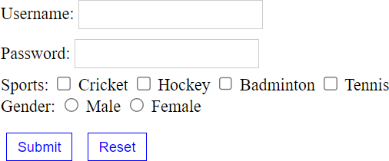

## Follow below requirements using HTML & CSS by a separate CSS file.

**Heading should have 120% font and right aligned.**

## In paragraph, the text color should be green, with bold, italic and times new roman font having 50px size.

**Take a background image repeated vertically only.**

## Ans. Code-

<!DOCTYPE html>

<html lang="en">

<head>

<meta charset="UTF-8">

<meta name="viewport" content="width=device-width, initial-scale=1.0">

<link rel="stylesheet" href="style.css">

<title>Index 7</title>

</head>

<body>

<h1 class="heading">Heading with Right Alignment</h1>

<p class="styled-paragraph">This is a styled paragraph with custom font, size, and color.</p>

</body>

</html>

.heading {

font-size: 120%; text-align: right;

}

/* Paragraph style */

.styled-paragraph { color: green; font-weight: bold; font-style: italic;

font-family: "Times New Roman", Times, serif; font-size: 50px;

}

/* Background image */ body {

background-image: url("./pic_trulli.jpg"); background-repeat: repeat-y; background-size: auto 100%;

}

**Output-**

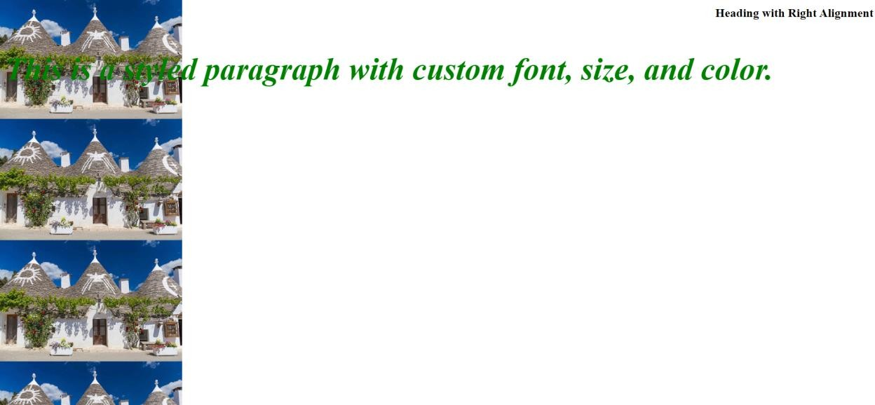

## Conclusion:

In this hands-on session, we gained fundamental insights into web development using HTML and CSS. HTML played a pivotal role in organizing web content through elements like headings, paragraphs, lists, links, and images. CSS, on the other hand, took charge of refining and presenting this content.

We delved into the crucial aspect of responsive design, which entails ensuring that web pages seamlessly adjust to various devices and screen dimensions. Furthermore, we ventured into the realm of enhancing user interaction by incorporating transitions and animations for dynamic web elements.

Collectively, this practical session furnished us with a robust groundwork for crafting websites that are both user-friendly and aesthetically engaging.

## References:

* https:/[/www.w3schools.com/html/](http://www.w3schools.com/html/)
* https:/[/www.w3schools.com/](http://www.w3schools.com/css/)c[ss/](http://www.w3schools.com/css/)